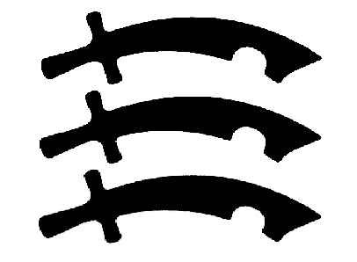
Essex County Council

exploRE

Essex scheme of work for RE at Key Stage 2
Hinduism  Hindu Gods and Goddesses: their Stories and Festivals

N.B. This study unit is different from others in that a great deal of background material is provided on Hindu gods and goddesses, their stories and festivals before suggested activities of a generic nature are introduced (see pages 20-22 for suggestions related to Hindu gods and goddesses, pages 23-25 for suggestions related to stories and pages 26-28 for suggestions related to festivals).

Statutory content from the programme of study for Key Stage 2 and learning objectives for AT1 (learning about religion) and AT2 (learning from religion) | Some themes to which the content could be linked
a) Hindu gods and goddesses  Key learning objectives – to enable pupils to:  - learn about different gods and goddesses by exploring the conventions of Hindu religious art (AT1)  - invent their own god or goddess and use the conventions of Hindu religious art to express their god’s attributes and qualities (AT2)  b) Stories associated with Hindu gods and goddesses  Key learning objectives – to enable pupils to:  - familiarise themselves with stories about Hindu gods and goddesses (AT1)  - appreciate the meaning and significance of the stories for Hindus (AT1)  - reflect on the stories to see whether they have anything to say to the children about their own lives (AT2)  c) Festivals associated with Hindu gods and goddesses  Key learning objectives – to enable pupils to:  - learn how Hindus celebrate festivals associated with various gods and goddesses (AT1)  - appreciate the meaning and significance of these festivals for Hindus (AT1)  - undertake activities which will help them capture the spirit of different festivals (AT1)  - devise their own festivals celebrating something in their own lives (AT2) | - Beliefs and teachings  - God  - Key stories  - Festivals and celebrations

Essex scheme of work for RE at Key Stage 2 HINDU GODS AND GODDESSES: THEIR STORIES AND FESTIVALS

Background notes for teachers
An extensive range of information is provided below on some of the most prominent Hindu gods and goddesses, their stories and their festivals. Some of the stories could be used with children in the versions given below but much of the material is written with the teacher rather than the child in mind. It is not intended that most of the subject matter will be presented to children as it appears below. It is intended that teachers will use a variety of pedagogies when teaching RE, and suggestions are provided at the end of this study unit.

Covered in these background notes:

Page number | Information about gods and goddesses | Stories associated with gods and goddesses | Festivals/celebrations associated with gods and goddesses
3. | The One (Brahman) and the many
4. | Ancient gods associated with the forces of nature: Indra, Surya and Agni
5. | Brahma
5. | Saraswati |  | - Saraswati Puja
6.-15. | Vishnu and the ten avatars of Vishnu (including Rama and Krishna):  - Matsya the fish  - Kurma the tortoise  - Varaha the wild boa  - Narasimha the man-lion  - Varama the dwarf  - Parasurama (Rama with an axe)  - Rama (and Sita and Hanuman) (p10)  - Krishna (and Radha) (p13)  - The Buddha  - Kalki | - The story of Matsya the fish (a flood story) (p7)  - The story of Kurma the tortoise (the churning of the sea of milk) (p8)  - The story of Varaha the wild boar (p8)  - The story of Narasimha the man-lion (p9)  - The story of Varama the dwarf (p9)  - The Ramayana (the story of Rama and Sita) (p11)  - Stories of Krishna’s birth (p13) and childhood (p14), Krishna and the gopis (p14) | - Holi (p9)  - Rama Navami (p10), Divali (p12), Navaratri (p12), Dassehra (p12)  - Janamashtami (p14), Holi (p15), Ratha-Yatra/Jagannatha (p15)
12. | Lakshmi |  | - Divali
15.-16. | Shiva and Shiva Nataraja | - The story behind the image of Shiva | - Mahashivratri
16. | Parvati
17. | Durga | - The story of Durga and Mahishasura the buffalo-demon | - Durga Puja
18. | Kali
18.-19. | Ganesh | - The story of how Ganesh acquired his elephant head  - The story of Ganesh, the rat, the snake and the moon | - Ganesh Chaturthi

The One (Brahman) and the many
- Hindus appear to believe in many different gods and goddesses but in fact they only believe in one God, Brahman. The many different gods and goddesses reveal different aspects of the One. The word ‘murti’ which is used to describe an image of a god, such as a picture or shrine figure, literally means ‘form’. Brahman may be glimpsed in the form of a man (Vishnu), a great hero (Rama), a faithful wife (Sita), a beautiful woman (Lakshmi), a woman of great refinement (Saraswati), a woman who is absolutely terrifying (Kali), a mischievous child and a flirtatious young man (Krishna), an animal (Hanuman), a person with the head of elephant enjoying a life of luxury and indulgence (Ganesh), a man living a life of strict self-denial (Shiva) and as the elemental forces of nature (Indra, Surya, Agni).

 Complementary Christian (and Muslim) content
- Hindus have many names for God, and so do Christians. The following are some of the titles given to God in the Bible: Creator (Isaiah 40.28), Father (Matthew 6.9), Judge (Genesis 18.25), King (Jeremiah 10.7), Lord (Psalm 113.1), Rock (Isaiah 17.10), Shepherd (Psalm 23.1), Shield (Psalm 18.2).
- Muslims have 99 ‘Beautiful Names’ for Allah.

Ancient gods associated with the forces of nature
The most ancient Hindu scriptures are the four Vedas, written between 1700 and 1500 BCE. The most important of the four Vedas is the Rig Veda, a collection of about a thousand hymns of praise to gods such as Indra, Surya and Agni. Like many gods of ancient peoples (the Egyptians, the Romans, the Greeks, the Norse people, etc) the Vedic gods were associated with nature: earth, air, fire, water, wind, the sun, the moon, trees, mountains, etc.

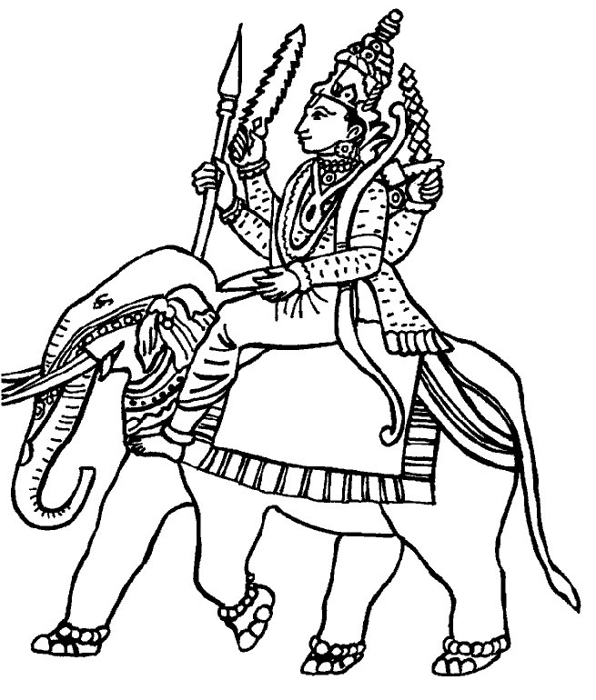  Indra | 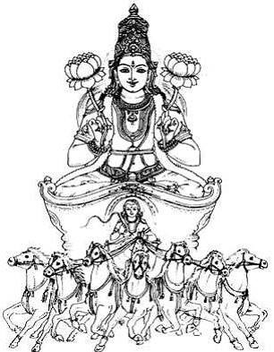  Surya | 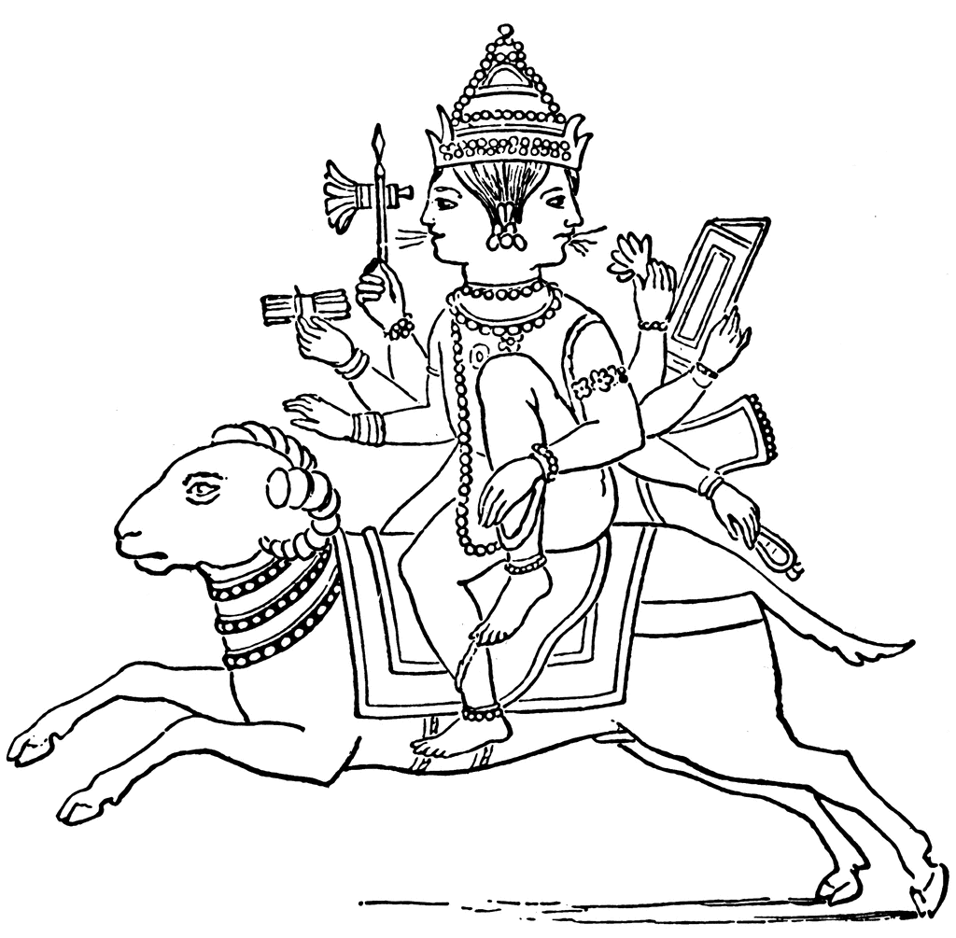  Agni

- Indra, king of the Vedic gods, is associated with the sky. He is the god of rain, thunder and lightning. He has two or four arms. He holds a variety of objects, including a bolt of lightning, lance, sword, bow and arrow, net and conch shell. He rides on an elephant with three trunks and/or four tusks. The story of the churning of the sea of milk (see section on Vishnu below) tells of how he saved the world and how he acquired the elephant on which he rides.
- Surya is the sun god. He rides across the sky in a chariot pulled either by seven horses or one horse with seven heads. He sometimes has two arms with a lotus in each hand. He sometimes has four arms. In his four hands he holds a variety of objects, including a lotus, wheel and conch shell.
- Agni is the god of fire. Part of Hindu worship is havan (offering of fire) and offerings of ghee (clarified butter) are made to Agni during havan. Agni has two heads and in each of his mouths there are seven fiery tongues. He uses these tongues to lick up the offerings of ghee that have been made to him. Agni has three legs and two or seven arms. He holds a variety of objects, including an axe, torch, prayer beads and flaming spear. He rides on the back of a ram or in a chariot pulled by fiery horses.
Brahma
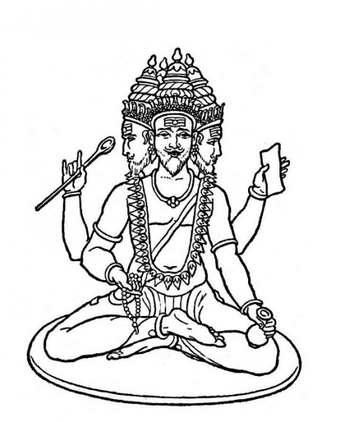 | - Brahma is the creator: he brings everything into existence. He is one of the Trimurti, the others being Vishnu (the preserver) and Shiva (the destroyer).  - Brahma has four faces. These enable him to read all four Vedas simultaneously and to look into every corner of creation at once.  - Brahma’s four arms represent the points of the compass, and in his four hands he carries a variety of objects. These include a water jug (a reminder of his function as the creator, since water is the source of all life), spoon (representing the offerings made to him in worship), sceptre, bow, book (the Vedas), a lotus and prayer beads (representing time).  - Brahma either rides a goose (symbol of wisdom) or stands or sits in the ‘full lotus’ posture on a large lotus.

Saraswati
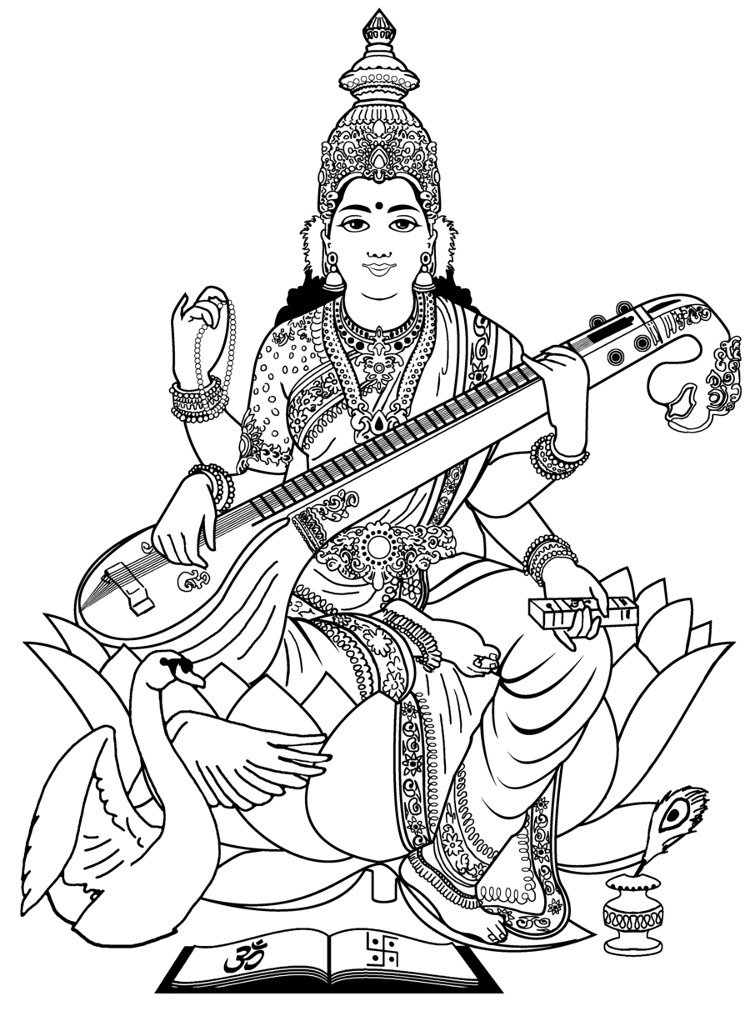 | - Saraswati is the beautiful wife of Brahma. She is the goddess of learning and the arts.  - Saraswati has a milky white face and dressed in white. She has four arms, representing mind, intellect, conscience and ego. With two of her hands she plays the vina (a stringed musical instrument resembling a sitar) and in the others she holds prayer beads and a book (the Vedas).  - Like Brahma, she either stands or sits on a lotus or rides a white goose. She is sometimes shown with a swan or a peacock

Saraswati Puja (celebration associated with Saraswati) – takes place January/February or September/October
- In most parts of India, Saraswati Puja (worship of Saraswati) takes place on the first night of Navaratri. Navratri is a festival lasting nine nights which takes place in September or October. In homes, all the sacred books are piled up and an image of Saraswati is placed on top. She is worshipped over a three day period.
- In north India, Saraswati Puja is performed in January or February as part of Vasanta Panchami or Shri Panchami, a festival celebrating the coming of spring. Since Saraswati is the goddess of learning, books and writing implements are not used on this day but are placed in front of the home shrine where puja (worship) in her honour is performed. In some areas, especially in West Bengal, clay images of Saraswati are carried in procession through the streets before being immersed in rivers or ponds. The following year, new images are made and immersed: a reminder of samsara (the cycle of life, death and reincarnation).
Vishnu
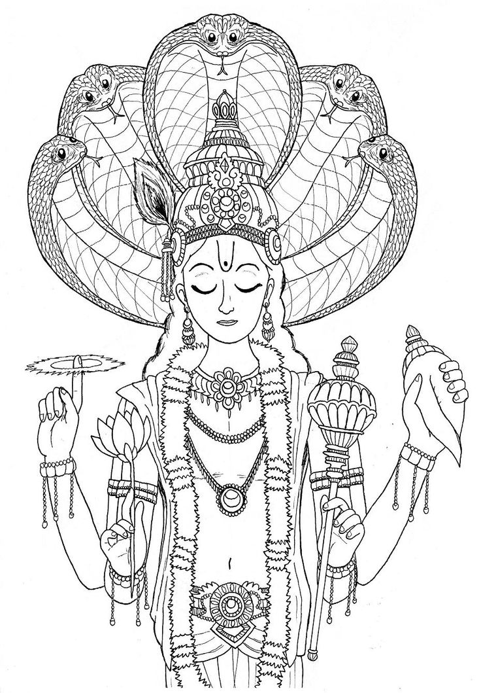 | - Vishnu is the preserver or sustainer of life. He is one of the Trimurti, the others being Brahma (the creator) and Shiva (the destroyer).  - Vishnu’s skin is blue because, like the sky, he is everywhere and he is everlasting. He has a distinctive U shaped mark upon his forehead, which is also worn by his devotees called Vaishnavites. In his four hands he holds a lotus, a conch shell, a club and a chakra (this circular weapon represents the solar disc and the cycle of life and death).  - Vishnu is often shown sitting or lying in the coils of Ananta or Shesha, the thousand headed serpent. As Vishnu Naryana he sleeps soundly in the serpent’s coils on the infinite cosmic ocean. Lakshmi his wife sits at his feet, and from his navel a lotus blooms. In the lotus flower sits Brahma, who is about to create the world and the first human beings.  - Vishnu rides Garuda, the king of the birds. Garuda is sometimes shown as half man and half bird.

The ten avatars of Vishnu
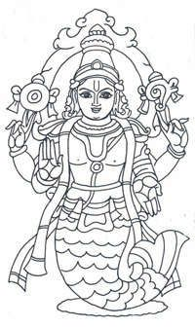  1. Matsya the fish | 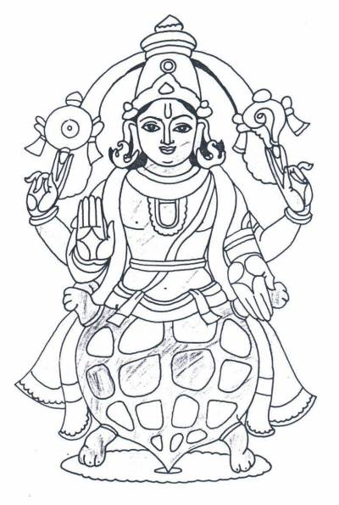  2. Kurma the tortoise | 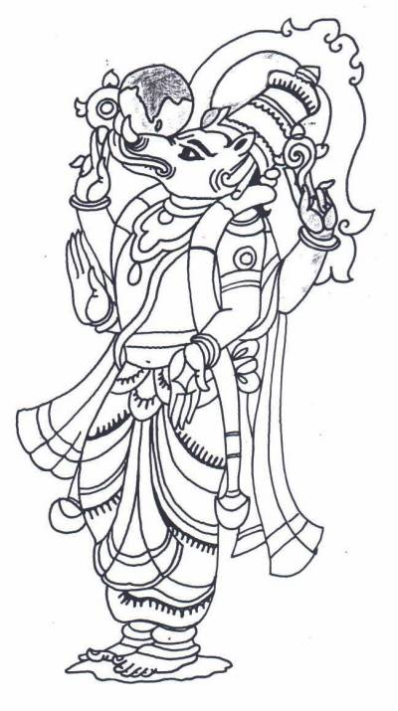  3. Varaha the boar | 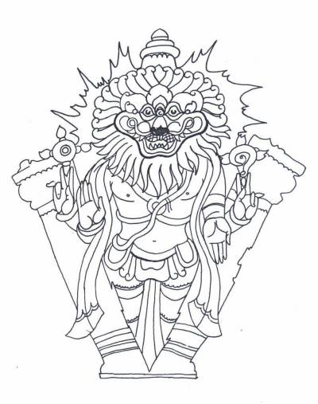  4. Narasimha the lion | 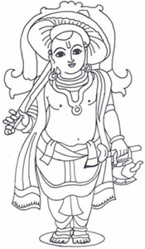  5. Varama the dwarf
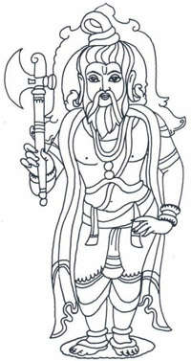  6. Parasurama | 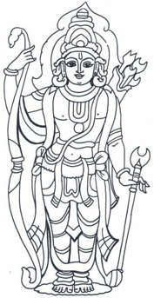  7. Rama | 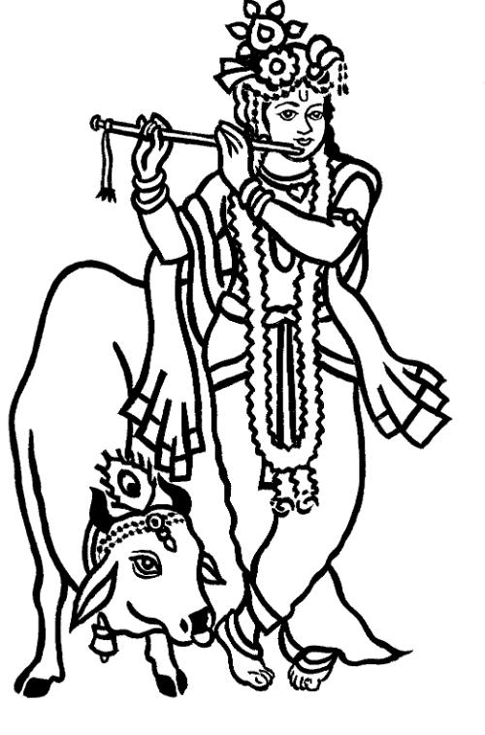  8. Krishna | 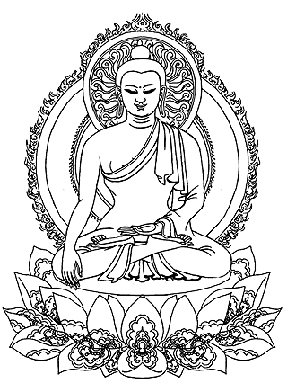  9. The Buddha | 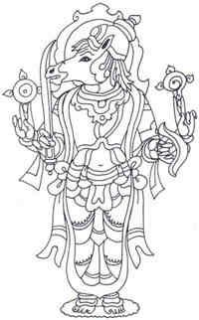  10. Kalki
- Vishnu protects the world from evil. When the world is threatened, he comes down in the form of an animal or a human to combat the forces of wickedness. The animal or human forms adopted by Vishnu are called avatars. An avatar literally means a descent or a coming down. Traditionally Vishnu has ten avatars (dashavatar). Stories associated with the first five avatars of Vishnu are re-told below.
  - Matsya – the fish
  - Kurma – the tortoise
  - Varaha – the wild boar
  - Narasimha – the man-lion
  - Varama – the dwarf
  - Parasurama – Rama with an axe
  - Rama – see below
  - Krishna – see below
  - The Buddha
  - Kalki – at the end of time, Kalki will appear riding on a white horse and brandishing a blazing sword to destroy the forces of evil

 Complementary Christian content
- Just as Hindus believe that Vishnu came down to earth in human form (as Rama, Krishna and the Buddha), so Christians believe that God appeared on earth in the person of Jesus.

1. The story of Matsya the fish (a flood story)
Flood stories feature in the mythologies of many cultures, and elements of this story have much in common with the Biblical story of Noah’s ark. Scholarly opinion is divided as to whether the two accounts have a shared original source or whether they grew up entirely independently.
- Manu, the very first man, was washing in the river when he scooped up a tiny fish. “Please help me,“ the fish pleaded. “If I stay in the river a bigger fish will eat me.” Manu took the fish home and put it in a jug of water. The following morning, the fish had grown so much that it filled the jug. Manu put it in a pond. The following morning, the fish had grown so much that it filled the pond. Manu put it back into the river. The following morning, the fish had grown so much that it filled the river. Manu put it into the sea. The fish spoke again to Manu, telling him that he was really the god Vishnu. He warned Manu that a terrible flood was coming. The fish told Manu that in order to save himself and other living things, he would need to build a great boat and fill it with two of every living creature and the seeds of every plant. When the flood came, the boat rose up on the waters. But now new danger loomed: a mighty storm threatened to sink the boat. Manu saw a great gleaming golden fish swimming towards him. It had a horn on its head. Manu threw a rope onto the horn and the fish pulled the boat to safety. In this way Vishnu saved all the creatures of the earth.

 Complementary Jewish/Christian content
- In both the Hindu story of Matsya and the flood and the Bible story of Noah’s ark (Genesis 6-8), a great boat is built to save two of every type of animal so they can reproduce when the flood waters subside.

2. The story of Kurma the tortoise (the churning of the sea of milk)
- The gods were worried. Their strength was ebbing away and they felt weaker by the day. Lord Vishnu spoke, “We need amrit, the liquid of immortality. If we could drink some of the magic liquid, our strength would return”. “How can we obtain it?” asked the other gods. “Only with the help of the demons”, replied Vishnu. The gods were horrified, but Vishnu persuaded them that there was no other way to get hold of the miraculous drink. As soon as the demons heard about the amazing properties of amrit, they agreed to help.
- So the forces of good and the forces of evil combined and Vishnu led them to the shores of the sea of milk. They looked out over the vast white expanse and Lord Vishnu spoke again, “In order to make amrit, we must churn the sea of milk”. The gods and the demons were full of doubt, “The sea is too big. How can we possibly churn it?“ Vishnu uprooted a huge mountain and turned it upside down. “This will be your churning stick”, he said, “And the giant snake Vasuki will be the rope you use to spin it”. Vishnu explained what they needed to do, and then in an instant he turned himself into a great tortoise called Kurma. The tortoise swam down to the bottom of the sea of milk, and the gods and demons positioned the mountain, point downwards, on its back. The tip of the mountain rested on the tortoise’s shell and acted as a pivot. Next they wound the snake Vasuki around the mountain. The gods held onto Vasuki’s tail while the demons gripped the neck. The gods pulled one way while the demons relaxed their grip. The demons pulled the other way while the gods relaxed their grip. Then it was the gods’ turn to pull again. As they tugged to and fro’, to and fro’, the mountain span like a giant spinning top churning the sea all around it.
- Faster and faster the mountain span one way and then another. As it did so, the friction generated caused the snake’s body to grow hotter and hotter. Suddenly fiery breath belched out of Vasuki’s mouth, lightning filled the sky, fires and streams of molten lava threatened to destroy the whole world. Indra the god of the sky now intervened. He pierced the clouds with thunderbolts and unleashed torrents of rain. The fires were extinguished, the lava was cooled and the gods and demons were refreshed.
- As the snake’s body stretched and twisted around the mountain, all of its poison welled up inside it and spewed out of its mouth. Streams of blue venom started to engulf the world. This time it was the god Shiva who came to the rescue. He swallowed the poison, but as he gulped it down it turned his throat blue. That is why Shiva is known as the ‘blue throated’.
- The gods and the demons were becoming exhausted and their bodies ached. At last their efforts were rewarded and the churning sea began to yield wonderful things. The moon emerged from the froth and the foam, followed by the sun. The goddess Lakshmi came out of the waves and an elephant too. Lakshmi later became the wife of Vishnu and the elephant became the mount of the god Indra. The sea also produced a magic horse, a milk-white cow, a sparkling jewel, a tree of paradise and the goddess of wine. Finally Dhavantari, god of healing, appeared bearing a cup in his hands. The tremendous efforts of the gods and the demons had not been in vain. The cup contained amrit, the liquid of immortality.
- Before the gods realised what was happening, the demons seized the cup and escaped down to the underworld. Once more it was Lord Vishnu who saved the gods. This time he turned himself into a beautiful woman, and then he went down to the underworld. The demons were so captivated by the beauty of this mysterious woman that they promised her she could have whatever she wanted. Naturally, she chose the cup of amrit which she then carried back to the gods. The gods drank the amrit and with their strength restored, they were able to defeat the demons.

3. The story of Varaha, the wild boar
- There was once a flood so great that the entire earth was covered in water. An evil demon kept the earth completely submerged under the flood water. Vishnu turned himself into a huge wild boar, forty miles wide and four thousand miles tall. He dived into the waters and found the earth by using his sense of smell. He killed the demon who was keeping the earth submerged and swam back up to the surface carrying the earth on his tusks.

4. The story of Narasimha, the man-lion
- Hiranya Kashyap was the king of the demons. He thought that he could never be killed. This was because the god Brahma had granted him a great favour. Brahma had promised the demon king that he could not be killed by any man or animal, by day or by night, in the open or under a roof, or by any weapon. Thinking himself safe from all danger, Hiranya Kashyap began a reign of terror. No one was spared. When he heard that his own son was worshipping the god Vishnu, the demon king decided to kill him. His son’s name was Prahlad.
- Hiranya Kashyap ordered his soldiers to dig a deep pit and to fill it with poisonous snakes. Prahlad was thrown into the pit. Many snakes bit him, but Lord Vishnu protected Prahlad and he did not die. The demon king then sent a herd of elephants to trample on Prahlad while he slept, but again Vishnu protected him and he remained unharmed. Hiranya Kashyap refused to give up and sent his soldiers with swords to kill Prahlad. Although he was stabbed many times, Prahlad again remained unhurt. Finally the demon king asked his evil sister Holika to help him kill his son. She said she would take Prahlad into the middle of a huge bonfire and hold onto him until he burned to death. She would protect herself from the flames by magic. Holika pulled Prahlad into the great bonfire and held tightly onto him while the flames raged around them. When the bonfire died down, with Vishnu’s protection, Prahlad emerged alive and unharmed. It was Holika that had been burned to death.
- Lord Vishnu now decided to put an end to the demon king. He knew that Hiranya Kashyap could not be killed by any man or animal, by day or by night, in the open or under a roof, or by any weapon. It seemed impossible to destroy the demon, but Vishnu found a way. He turned himself into a creature called Narasimha that was half man and half lion (neither man nor animal) and attacked the demon at twilight (when it was neither day nor night) in the doorway of his palace (neither in the open nor under a roof) with his claws (so no weapon was used). Thanks to Vishnu’s cleverness, Hiranya Kashyap, king of the demons, was destroyed.

Holi (festival associated with Narasimha) – takes place February/March
- The story of how the god Vishnu (in the form of the man-lion Narasimha) overcame Hiranya Kashyap (the demon king) is one of those recalled during the festival of Holi. Bonfires are lit to recall the destruction of Holika, from whom the festival takes its name. The festival is also associated with Krishna (see below).

5. The story of Varama, the dwarf
- The earth had been conquered by an evil demon called Bali. Vishnu came to Bali in the form of a dwarf called Varama. “Please let me have some land,” the dwarf asked the demon. “I don’t want much. Just let me have what I can cover in three steps.” Bali the demon laughed, “Look how short your legs are! Three steps won’t take you very far. Very well, you can have the land.” Vamana now grew so enormous that his first step covered the entire earth. With his second step he crossed the heavens. And when he took his third step he trapped Bali’s head under his foot and pushed him down into the underworld.

Rama, Sita and Hanuman (the picture below shows them with Lakshman)

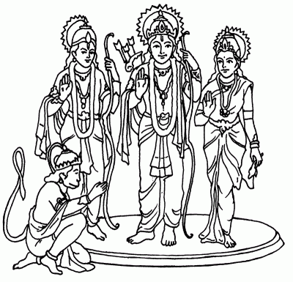 | - Rama (the seventh avatar of Vishnu) is the hero of the Ramayana, an ancient epic poem that tells the story of how he rescued his wife Sita from the clutches of the evil demon Ravana. He was helped in this by his brother Lakshman and Hanuman, the monkey god. For Hindus, Rama and Sita represent the ideal man and the ideal woman united in an ideal love. The story affirms that whatever difficulties and suffering are encountered along the way, if people show love and loyalty to each other goodness will ultimately overcome evil.  - Rama’s skin is blue and he wears the U shaped mark of Vishnu on his forehead. He carries a bow. He is often shown standing between his wife Sita and his brother Lakshman with Hanuman kneeling at his feet.  - Hanuman, the monkey god, is the faithful friend and helper of Rama. He is revered for his devotion, loyalty and strength. In one hand he carries a club, and in the other a mountain. The reason for this is that Lakshman, Rama’s brother, was seriously injured during the battle with the demon Ravana. Hanuman was sent to collect healing herbs from a mountainside, but when he got there, he was unsure about which herbs to pick. To solve the problem, he simply picked up the entire mountain and carried it back to Lakshman, thus saving his life.

Rama Navami (festival celebrating birth of Rama) – takes place March/April
- Rama Navami celebrates Rama’s birth. In homes and mandirs (temples) images or pictures of the infant Rama are placed in cradles which are uncovered at midday. Worshippers take it in turns to rock the cradle. In some places, images of Rama, Sita, Lakshman and Hanuman are carried in procession around the streets.

 Complementary Christian content
- Just as Hindus celebrate the birth of Rama (a god in human form) at Rama Navami, so Christians celebrate the birth of Jesus (God in human form) at Christmas.

The Ramayana (the story of Rama and Sita)
The Ramayana, which tells the story of Rama and Sita, is one of the world’s great epic poems. It cannot be dated with accuracy; but it was probably first written down between 200 BCE and 200 CE. It was composed in Sanskrit and according to tradition, was the work of one man, the sage Valmiki. For Hindus, Rama and Sita represent the ideal man and the ideal woman united in an ideal love. The story affirms that whatever difficulties and suffering are encountered along the way, if people show love and loyalty to each other goodness will ultimately overcome evil. At the end of the story lamps or ‘divas’ are lit, welcoming Rama and Sita back to their kingdom after fourteen years of exile. These ‘divas’ give their name to the festival of Divali (see below), which literally means ‘row of lights’. During Divali, the story is recalled in many different ways: through song, dance, plays and puppetry, including the use of shadow puppets. A brief summary of the story of Rama and Sita is provided below.
- There was once a beautiful princess called Sita. Many men wished to marry her. Her father, the king, decided that there would be a test to see who was worthy enough to marry his daughter. The king owned an enormous bow. The bow was so big and strong that no one had ever managed to put a string on it. The king announced that he would give Sita in marriage to the first man who succeeded in stringing the bow. Many tried, and all failed. The bow was so heavy that no one could even lift it from the ground! Then Prince Rama arrived. He picked up the bow as though it weighed nothing. When he bent the great bow in order to slot in the string, it snapped in half. The king was delighted – and so was Sita. At a magnificent wedding ceremony, Sita became Rama’s wife.
- Rama and Sita’s happiness was not to last. After the wedding they journeyed to Ayodhya where Rama’s father, Dasharatha, ruled as king. With great sadness, the old king told Rama that many years before he had promised two wishes to his wife, Rama’s step mother. She had never claimed the wishes – until now. Her first wish was that Rama should be banished from the kingdom. Her second wish was that her son, Bharata, should rule as king instead of Rama. Rama knew that as king, his father had to keep his promises, so accompanied by the faithful Sita and his brother Lakshman, he went into exile in the forest. Bharata became king, but, by placing Rama’s shoes on the throne, he showed that he was only king until Rama’s return.
- One day, Sita saw a beautiful deer running through the forest where they lived. Its golden coat was studded with jewels. She asked Rama to catch it for her. Leaving Sita under Lakshman’s protection, Rama gave chase and disappeared into the forest. A little later, Sita and Lakshman heard a cry for help. It sounded like Rama’s voice. They didn’t realise that the deer had been sent by Ravana, an evil ten-headed demon, to lure Rama away from Sita. It was the deer that had called out, in a voice that sounded just like Rama’s. Lakshman feared a trick and was reluctant to leave Sita unprotected, but she persuaded him to go and rescue Rama. This gave Ravana his chance. He seized Sita and carried her off to his island kingdom of Lanka where he imprisoned her.
- Rama and Lakshman eventually found out where Ravana was holding Sita, and with the help of Hanuman, the monkey-king, and his monkey army, they built a bridge from the mainland to the island of Lanka. After many weeks of fighting, during the last terrible battle, Rama faced Ravana alone. Rama drew back his bow and shot a special arrow at Ravana. This was Indra’s dart, with a tip made from sunlight and fire. The arrow pierced Ravana’s heart and the demon lay dead. Rama and Sita were re-united, and after fourteen years of exile they returned to the kingdom of Ayodhya. Bharata welcomed his half-brother as the rightful king and everyone celebrated. Thousands of divas (small clay lamps) were lit to welcome them home, an event recalled during the festival of Divali.

Divali (festival of lights associated with Rama and Sita) – takes place October/November
- During Divali, lights (divas) are lit to recall the return of Rama and Sita to their kingdom.
- Divali takes place in October or November and it lasts between two and five days. It is the most widely celebrated of all Indian festivals and the celebrations take on a variety of local forms. For some Hindus, it celebrates the new year. In the days leading up to Divali, homes and business premises are cleaned and redecorated. During the festival, gifts and cards are exchanged.
- Divali means ‘row of lights’. During the festival, divas (small clay lamps) were traditionally put along window ledges and on the roofs of houses. Today strings of electric lights are often used instead. The lights recall the story of Rama and Sita, when the people of Ayodhya lit lamps to celebrate the return of Rama, their rightful king. The lights also symbolise the triumph of good (Rama) over evil (Ravana).

 Complementary Christian content
- At Christmas, churches are filled with lights representing Jesus, the light of the world.
- At Easter, the Paschal candle is lit and churches are filled with light. This symbolises the triumph of life over death, of good over evil, of God over the forces of darkness.

Navaratri and Dassehra (festivals associated with Rama and Sita) – take place September/October
- In some parts of north India, during the nine nights of Navaratri, troupes of actors tour the villages performing plays telling the story of Rama and Sita. In Delhi the story is acted out over the nine nights of Navaratri and then on the tenth night, called Dassehra, the actor playing Rama shoots an arrow into a huge firework-filled effigy of Ravana, which bursts into flame.

Lakshmi
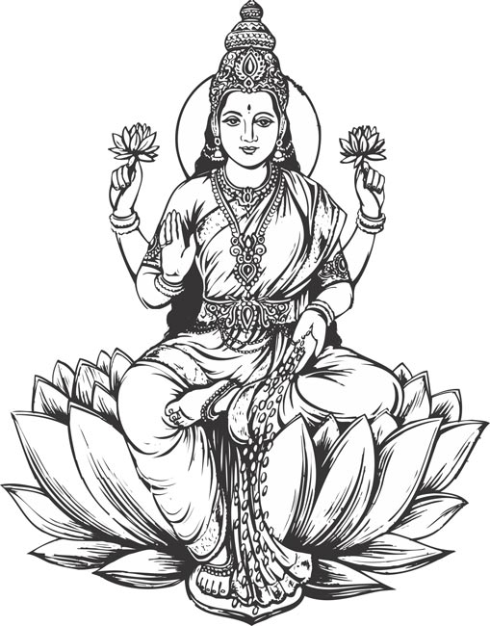 | - Lakshmi is the wife of Vishnu. She is the goddess of wealth, prosperity and happiness. When shown with Vishnu, she has two arms. When shown alone, she has four. In two of her hands she holds lotus flowers. With her other hands she bestows gifts, including gold coins. Lakshmi stands or sits on a lotus and sometime she is attended by elephants on either side.  - Lakshmi is always shown carrying lotus flowers. The lotus rises from the dark muddy depths of the pool to achieve its full beauty and flowering in the light. In the same way, human beings have the capacity to rise up out of their earthly condition and to achieve spiritual purity.  - Just as Rama is one of the ten avatars of the god Vishnu (see above), so Sita is an avatar of the goddess Lakshmi.

Divali (festival of lights associated with Lakshmi) – takes place October/November
- During Divali, lights (divas) are lit to welcome Lakshmi into Hindu homes. To attract the goddess into the home, elaborate rangoli patterns (made from coloured rice paste, sand, chalks or flour) are painstakingly created on floors at the entrance to the home.
- Lakshmi Puja (worship of Lakshmi) is a central feature of Divali. In some places, business accounts are closed before taking part in Lakshmi Puja. In homes and temples, coins are piled on ledgers and an image of the goddess is placed on top.
Krishna and Radha
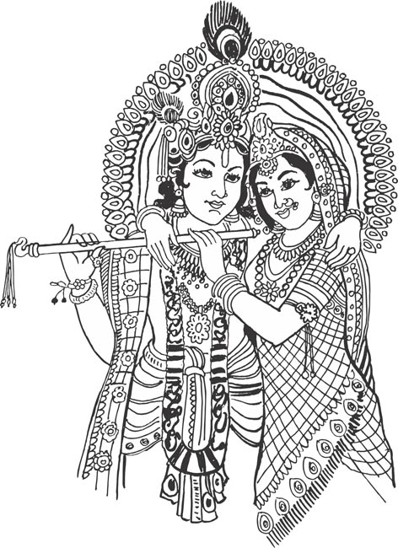 | - Krishna (the eighth and most popular avatar of Vishnu) is worshipped by millions of Hindus as a god in his own right. Krishna’s teaching is contained in the Bhagavad Gita (the Song of the Lord), regarded by most Hindus as their most important scripture. The setting of the Bhagavad Gita is a battlefield. Arjuna, leader of one of the warring factions, rides up and down in his chariot between the two opposing armies contemplating and questioning the dreadful carnage that is about to take place. His charioteer is none other than Krishna who enters into a lengthy philosophical dialogue with Arjuna. Krishna’s teaching about bhakti (love) and dharma (duty) lies at the heart of modern Hinduism.  - Krishna literally means black and his skin is either black or blue, like that of Vishnu. He carries a flute, bears the U shaped mark of Vishnu on his forehead and wears a peacock feather in his hair. He is often shown with a white cow, recalling the cows in the village of Gokul where he grew up, and he is sometimes called Govinda, meaning finder of cattle.  - Krishna is accompanied by the beautiful Radha, his favourite among all the village gopis, as the girls who tended the cows were known. The reciprocal love and devotion that exists between Krishna and Radha reflects that which exists between Krishna and his followers. When Krishna and Radha are shown together, the image embodies the two aspects of the Divine (male and female), which together form the One.
The story of Krishna’s birth
- The demon-king Kamsa was evil and cruel. He was also worried. One of his advisers had prophesied that his sister, Devaki, would give birth to a child that would kill him. Kamsa gave orders that Devaki should be imprisoned together with her husband, Vasudeva. The couple had six children in prison. As each baby was born, the child was taken away and killed.
- The god Vishnu decided to intervene. Devaki became pregnant and gave birth to a baby boy called Krishna (really an avatar of Vishnu). Krishna was born at midnight, and as soon as he was born, he stood up and spoke to Vasudeva, his father. The baby Krishna told Vasudeva to exchange him with a baby girl who had been born to the wife of a cowherd called Nanda. Nanda’s dwelling was in the village of Gokul on the far side of the river Yamuna.
- No sooner had Krishna spoken, than the chains that were holding his father broke, the guards fell into a deep sleep, and the doors of the prison swung open. Carrying his child in a basket, Vasudeva ran until he stood on the banks of the Yamuna. Now his heart sank, for the great river was in flood. However, as soon as he stepped into the raging torrent, the waters parted and he was able to cross safely to the other side. He wasted no time in finding Nanda’s house, where he secretly exchanged Krishna for the cowherd’s daughter.
- Vasudeva returned safely to the prison (the waters of the Yamuna again divided to allow him to pass), and there he placed the baby girl in Krishna’s cradle. The prison doors slammed shut and the broken chains became whole again. The baby’s cries roused the guards, who hurried to tell Kamsa that his sister had given birth to another child.
- As soon as Kamsa heard the news, he rushed to the prison with a drawn sword in his hand. As the evil demon-king approached the baby with his sword raised ready to kill her, she stood up in her cot and told him that she was really the goddess Yogamaya and that Krishna was alive and well. One day the prophecy would come true, and Krishna would kill the evil king.
- Meanwhile Krishna had an idyllic upbringing in the beautiful village of Gokul (the name of Vrindavan and its surrounding area), where the cows grazed peacefully on the river banks. Nanda and his wife Yashoda raised Krishna as their own son. They had another son called Balarama and like any other brothers, the two little boys frequently got into trouble for their mischievous games.
Janamashtami (festival celebrating birth of Krishna) – takes place August/September
- Janamashtami celebrates the birth of Krishna. Many Hindus fast until midnight, when Krishna is said to have been born. The baby god is then greeted with singing and dancing and food offerings. In Hindu homes and mandirs (temples), images of the baby Krishna are placed on small swings or in cradles. Worshippers take it in turns to swing or rock the baby Krishna.

 Complementary Christian content
- Just as Hindus celebrate the birth of Krishna (a god in human form) at Janamashtami, so Christians celebrate the birth of Jesus (God in human form) at Christmas.

Stories of Krishna’s childhood
- One day, Krishna’s brother Balarama told Yashoda, their mother, that he had been eating soil from the ground. When Yashoda asked Krishna to open his mouth, she looked inside and saw the earth, the sun, the moon and the stars. As a god, the whole universe was contained within him.
- Krishna loved butter and he was always stealing freshly churned butter from his exasperated mother. One day, Yashoda had had enough. To prevent him from stealing the butter, she got a rope to tie him up. Although the piece of rope seemed long enough, when she attempted to bind Krishna she found it was to short. She got another length of rope and tied it to the first. It still wasn’t long enough. However many pieces of rope she tied together, Krishna could not be tied up. After all, he was really a god.
- The peace enjoyed by the villagers of Gokul was once disturbed by Kaliya, the many-headed serpent king. Kaliya swam up the river Yamuna spewing poison into the waters. Cows and children drinking the river water were killed. Krishna climbed a tree and looked down into the river. He spotted the fearsome serpent beneath the water and dived in. The water churned and frothed. The villagers feared Krishna had been killed. Then the many heads of the giant snake loomed up above the surface, and Krishna could be seen dancing across them. Faster and faster he danced, and as he did so, Kaliya grew weary and his heads began to sink back down into the water. If Krishna kept on dancing, the serpent king knew he would die. He begged Krishna to spare him. Krishna understood that it was in Kaliya’s nature to kill, just as it was in a cat’s nature to kill a mouse. In acting violently, the serpent was merely living according to his dharma, his nature, his duty. Krishna therefore showed Kaliya mercy. He let him live but banished him to the deepest depths of the ocean.

Stories of Krishna and the gopis (girls who tended cows)
- It was baking hot day in the village of Gokul. The gopis (the girls who tended the cows) went down to the river to bathe. They put their clothes in neat piles on the river bank and started splashing in the cool water. Krishna, who was looking after a herd of cows, heard the sound of their laughter. Chuckling to himself, he crept up to the river bank, gathered up the girls’ clothes and climbed a tree. Then he called out to the gopis, saying that he wouldn’t let them have their clothes back unless they came out of the river to collect them. The girls had no choice, and as they came up to the tree, he dropped their clothes onto the ground. When he told the girls how beautiful they all were, this pleased them so much that they forgave him for playing the trick on them. Some Hindus say the story illustrates the fact that God sees us as we truly are.
- It was warm summer night in the village of Gokul. The moon shone bright in a clear sky. All the gopis (the girls who tended the cows) wanted to dance with the handsome Krishna. They went up to him one at a time and asked him to dance with them. Krishna multiplied himself so that instead of just one Krishna, there were many Krishnas: one for each of the gopis. As each girl danced, she was convinced that she was dancing with the real Krishna. But Krishna had saved his true self for the girl he loved best: the beautiful Radha. And with Radha alone the real Krishna danced.
Holi (festival associated with Krishna) – takes place February/March
- Krishna’s flirtatious frolics with the gopis are recalled during Holi. The festival is associated with spring: the bright colours recall the colours of blossom and flowers and the abundance of water is a reminder of the life-giving properties of rain (Holi marks the end of the dry season). It is a very boisterous festival. During Holi, everyone goes through the streets throwing brightly coloured powder over each other. Pichkaris (large syringes resembling bicycle pumps) are used to squirt water at victims. No one is immune from attack. It doesn’t matter what social position people hold, for Holi they will need to wear old clothing and accept the fact they are going to end up drenched and covered in multicoloured powder!
- Holi is also associated with the story of Prahlad and Holika, see the story of Narasimha, the man-lion, above.

Ratha-Yatra or Jagannatha (festival associated with Krishna) – takes place June/July
- A characteristic feature of many Hindu festivals is the procession of images of various deities through the streets. The images are often carried on large wheeled vehicles. The most spectacular procession of all takes place annually in the city of Puri in Orissa. It is known as the Ratha-Yatra (chariot journey). Every year, the image of Krishna is brought out of the mandir (temple) to be bathed, anointed, cleaned and repainted. It is then placed on a huge wooden cart (about 15 metres high) and towed by hundreds, or even thousands, of people to another mandir in the city. The same thing happens to images of Subhadra, Krishna’s sister, and Balarama, his brother. After a few days, the three images are pulled back to their original shrines The English word ‘juggernaut’ comes from the name by which Krishna is known during this festival: Jagannatha.

Shiva
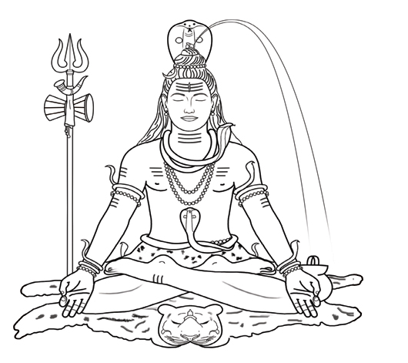 | - Shiva is the destroyer of life, but his destructive energy (shakti) paves the way for renewal. He is one of the Trimurti, the others being Brahma (the creator) and Shiva (the preserver).  - Shiva is usually shown as a holy man sitting on top of the Himalayas deep in meditation. He sits in the ‘full lotus’ posture on a tiger skin or a lotus, wearing nothing but a simple loin cloth or an antelope skin. In Shiva’s hair there is a crescent moon. At the top of his head there is either a fountain of water, representing the source of the river Ganges, or the face of Ganga, the river goddess. Snakes twist through his hair and entwine his neck. Shiva has three eyes, to perceive the past, present and future. In his four hands he holds a trident (representing the Trimurti: Brahma, Vishnu and Shiva), a hand-drum (symbolising the original sound of creation) and a water jug (symbolising renewal).
The story behind the image of Shiva
- A Rishi is a person who is spiritually wise. One would normally expect a Rishi to act with self-restraint, but on one occasion, ten thousand Rishis became so angry that they acted with great foolishness. The reason for their anger was that all of their wives had fallen in love with the handsome god Shiva. In their jealous rage, the Rishis sent a wild tiger and then an antelope to attack Shiva, but he killed and skinned them with his bare hands. Shiva tamed the poisonous snakes which the Rishis sent, and wore them in his hair and around his neck. He caught the red hot iron and the crescent-shaped sickle that the Rishis hurled, making a weapon from the iron and using the moon sickle as an ornament in his hair. Finally, the Rishis sent an evil black dwarf to kill Shiva, but the god knocked the dwarf onto the ground and danced on his belly. Acknowledging Shiva’s true greatness, the Rishis bowed down before him and worshipped him.
Shiva Nataraja
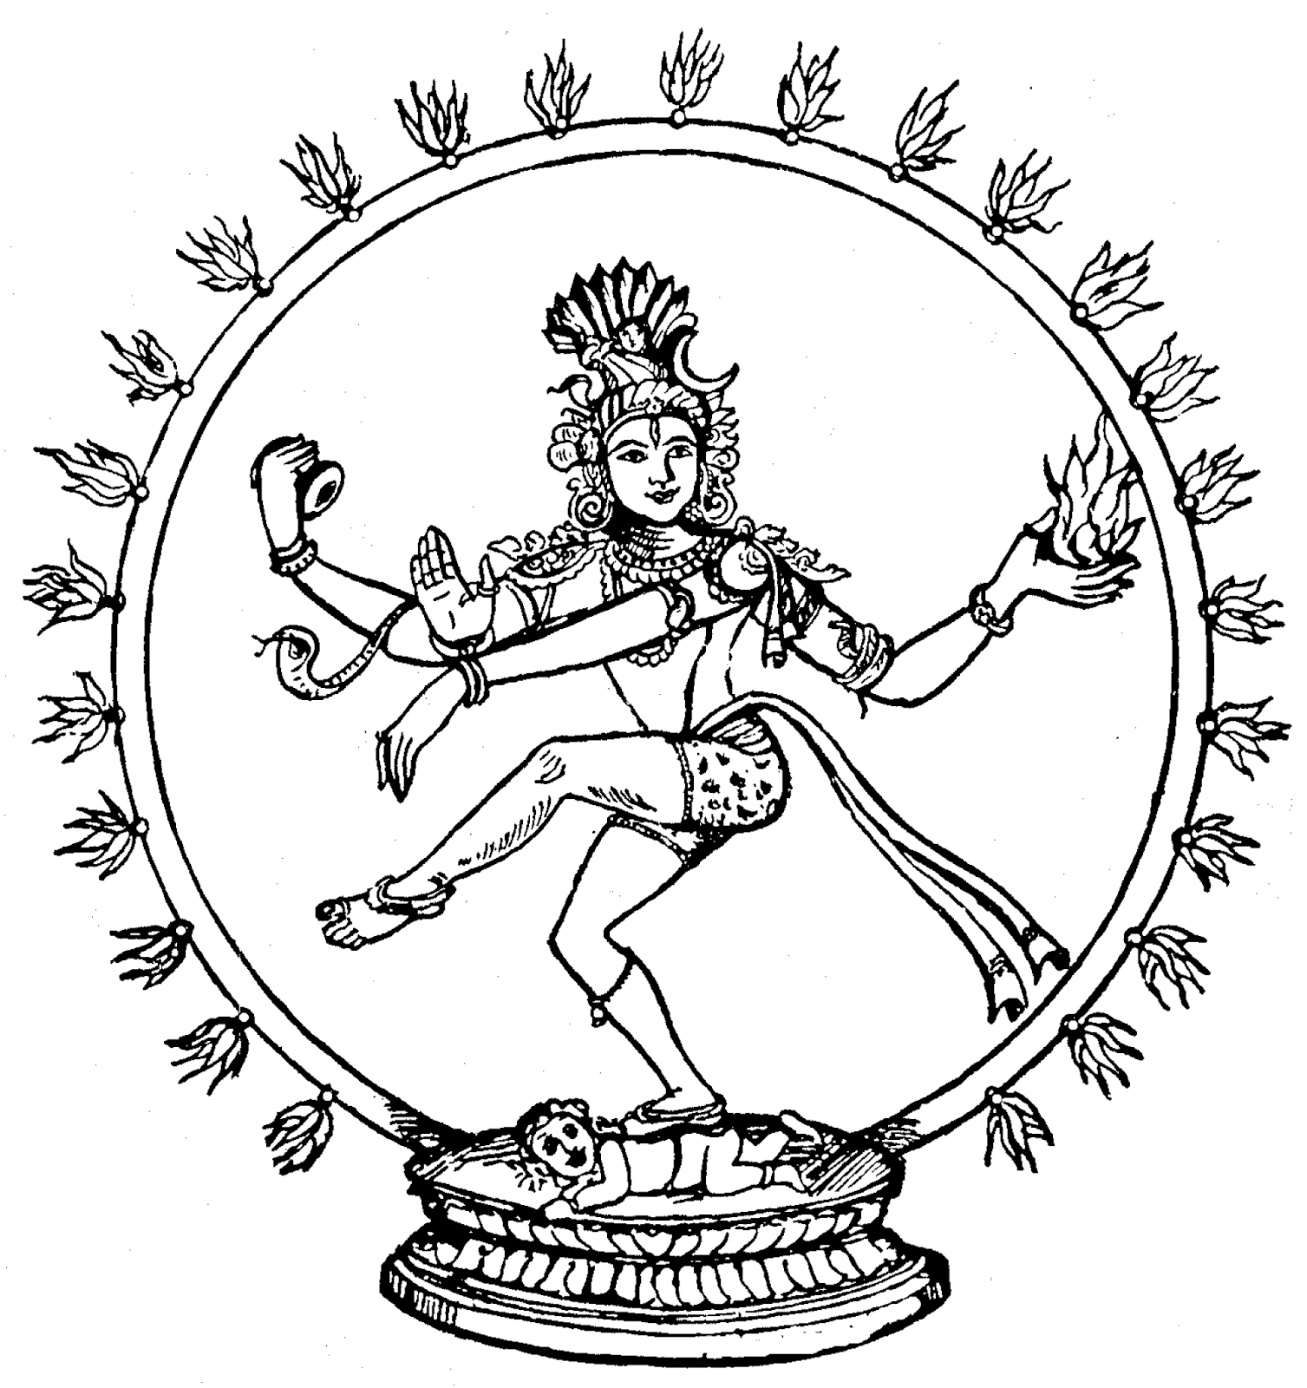 | - Shiva is often depicted as Shiva Nataraja (the Lord of the Dance). In this form, he dances in a circle of flames with his hair flying out on all sides. The circle represents time, with no beginning or end. The flames symbolise shakti (energy) in its purest form, and also serve as a reminder of the fires of cremation. In one of Shiva’s four hands he holds a small drum. The sound of the drum is the sound of creation. Sometimes Shiva stops playing the drum, in order to find a new and better rhythm. At that moment the universe ends, to be recreated when the music restarts. Shiva holds a flame in the palm of another hand, revealing his ability to destroy the universe. Another hand flops down from an arm stretched across his body. This arm represents the trunk of an elephant, and the gesture symbolises strength. With his right foot, Shiva tramples the dwarf of ignorance.  - Hindus have the idea that the whole of creation is taking part in a great cosmic dance: the planets dance around the sun; the seas dance up and down; the sun and moon dance across the sky; the plants, the trees and the clouds dance in the wind, etc. Shiva’s energy fills the universe and the dance of the cosmos is the dance of Shiva. This means that although Shiva is associated with death and destruction, he is also associated with energy, renewal and rebirth.

Mahashivratri (festival associated with Shiva) – takes place January/February
- According to Hindu mythology, on the night known as Mahashivratri (Great Shiva Night) Shiva performs the cosmic dance of creation and destruction. Some of his devotees spend the whole of this night singing his praises and reading sacred texts. The following day, special celebrations are held throughout India at temples dedicated to Shiva.

Parvati
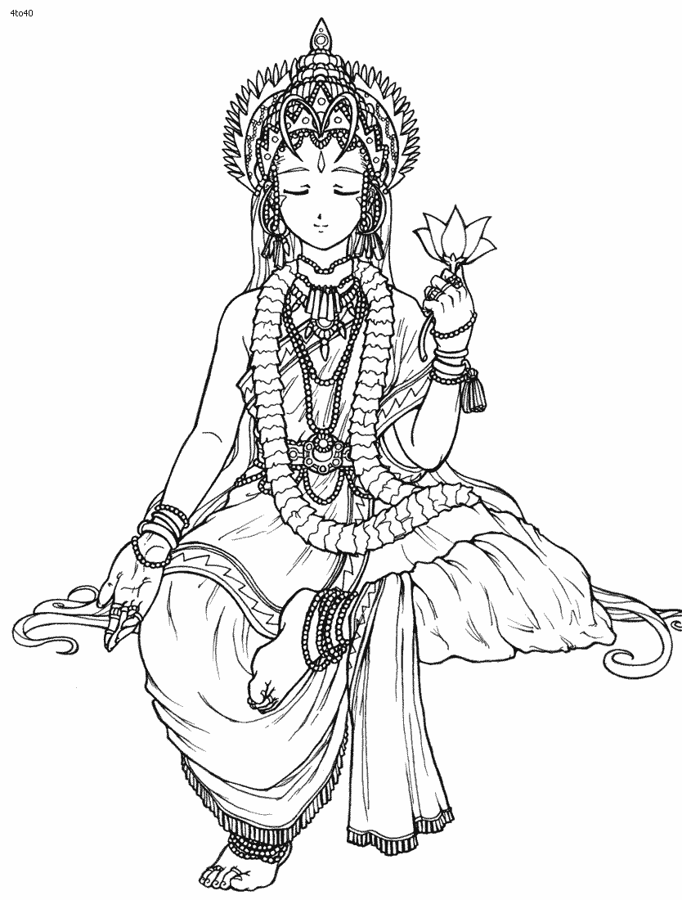 | - As Shiva’s wife, the goddess Parvati is the most important embodiment of shakti (energy or power, seen as female). Shakti is also embodied in the forms of the goddesses Durga and Kali (see below).  - Shiva and Parvati are often shown together. Sometimes Parvati sits on Shiva’s knee while he embraces her, sometimes they stand side by side, and sometimes they are depicted as lovers. As with Radha and Krishna, images of Parvati and Shiva together embody the two aspects of the Divine (male and female), which together form the One.
Durga
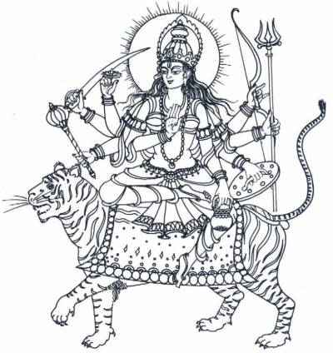 | - Shakti (energy or power, seen as female) is manifested in the ferocious form of Durga (the one who is difficult to approach). Durga has eight arms and carries many weapons with which to combat evil demons, such as Mahishasura the buffalo-demon (see story below). The objects in her eight hands include a trident, sword, snake, bell, drum, shield, skull bowl, bow and arrow, wheel, club, water jug and conch shell. Durga rides a lion or a tiger.

The story of Durga and Mahishasura the buffalo-demon
- Mahishasura, the evil buffalo-demon, was threatening to destroy the earth and all the gods. None of the gods was strong enough to defeat him. They decided to send the goddess Durga against him and they armed her with an array of weapons including Shiva’s trident, Vishnu’s disc, Agni’s dart, Surya’s arrows and Indra’s thunderbolt.
- Riding on a ferocious lion, Durga led her army against Mahishasura’s forces. When it became apparent that her army was winning, the buffalo-demon flew into a terrible rage. The earth shook and the waters foamed. Mahishasura thundered towards Durga, lashing out with his horns, his hooves and his tail and killing many of her followers.
- Durga succeeded in lassooing him, but he turned into a lion and escaped. Durga gave chase and cut off the lion’s head, but he turned into a man. Durga shot the man with arrows, but he turned into an elephant. Durga cut off the elephant’s trunk, but he turned back into a buffalo. Durga leapt onto the buffalo’s neck and plunged Shiva’s trident into him. At last Mahishasura lay dead. All of creation rejoiced, except for the forces of evil, who ran away in confusion.

Durga Puja (festival associated with Durga) – takes place September/October
- In west Bengal and surrounding states, Navaratri (the festival of nine nights) is known as Durga Puja. The goddess’s victory over Mahishasura the buffalo-demon is central to the celebrations. Images of Durga are worshipped for nine days and on the tenth day (Dassehra) they are carried in procession and immersed in rivers or ponds. The following year, new images are made and immersed: a reminder of samsara (the cycle of life, death and reincarnation).
Kali
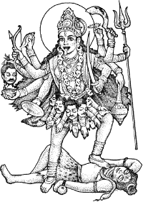 | - Shakti (energy or power, seen as female) is manifested in the terrifying form of Kali (the Black One). Kali is associated with night and darkness, and she reminds her devotees of the reality of negative aspects of existence: suffering and death, fear and despair. Her followers seek her protection from these aspects of experience. Kali symbolises the destruction of the world in order that it can be recreated. She devours everything in her path. Her tongue hangs out, dripping with the blood of her victims. She wears a necklace of skulls and severed arms hang from her waist. She holds a severed head in one of her four hands, and in another she wields a sickle. Not even Shiva can stand against her: she subjugates him completely and is often shown dancing on his body.

Ganesh
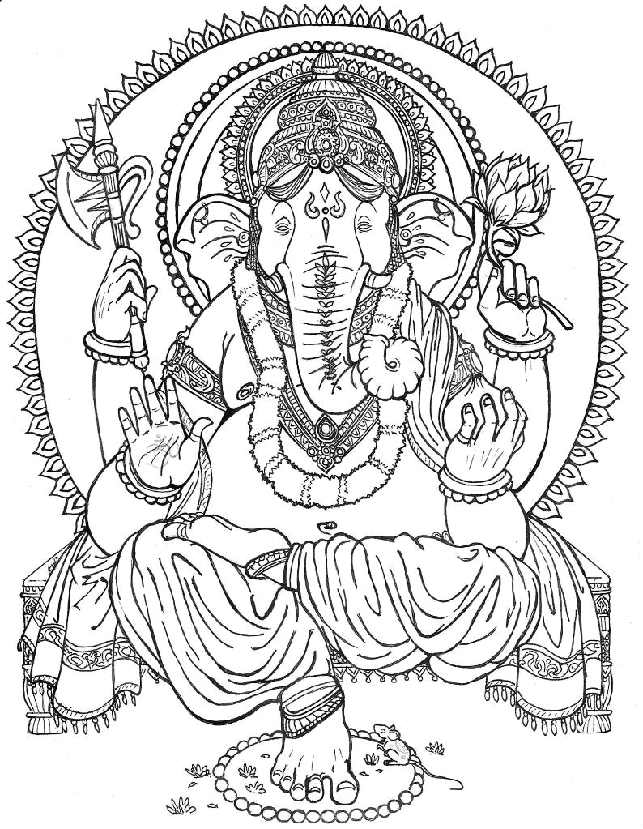 | - Ganesh is the elephant-headed son of Shiva and Parvati (see story below), and like his father he sometimes dances a powerful dance which reveals the heartbeat of the universe. Ganesh is one of the most popular Hindu deities and images of him are seen everywhere in India: in homes, in shops, on cars, on buses, as well as in shrines and mandirs (temples).  - Ganesh brings good fortune and success. Just as elephants clear a pathway through the jungle, so Ganesh provides a smooth way ahead. He is known as the remover of obstacles and prayers are said to him at the start of undertakings, such as journeys, puja (worship), school terms or new ventures.  - Ganesh is always shown richly dressed in a sumptuous setting with a rat at his feet. His four arms indicate that he is more than a human being, and in his four hands he holds a variety of objects, including a noose (for catching elephants), a goad (for guiding elephants), one of his own tusks and a dish of sweets which he sniffs with his trunk. His large stomach shows that he is able to take in and absorb everything that the world contains. He can deal with or ‘digest’ whatever experiences life brings. His round belly also reminds us that it is acceptable to indulge oneself occasionally: earthly delights do not have to be an obstacle to profound spiritual insights. His large ears show that he listens. He listens to people when they pray to him, he listens when people ask him for help and he listens in order to acquire knowledge and wisdom. His head shows that he possesses the positive qualities associated with elephants: gentleness, patience, perseverance, strength, intelligence, etc.
The story of how Ganesh acquired his elephant head (there are many different version of this story)
- The god Shiva and his wife Parvati were devoted to each other and they lived happily together. There was just one thing that marred their joy: they did not have any children. One day, while Parvati was bathing, she took some soap and moulded it, with a few flakes of her skin, into a human shape. When she breathed on the tiny figure, it came to life. The figure grew into a handsome boy, whom she named Ganesh.
- Shiva sometimes had to leave his wife to assist the other gods in their perpetual battles against the forces of evil. When Shiva wasn’t there to protect Parvati, Ganesh always stood guard. On one occasion, Shiva had been away for so long that when he returned, he did not recognize the boy who stood barring his way. When Ganesh refused to let him enter his own home, Shiva lost his temper and in the heat of the moment he struck off the boy’s head.
- Parvati was heartbroken, and so Shiva promised to make amends. He sent his servants to find the head of another child, but every child they found was gazing at its mother and they did not have the heart to separate them. Eventually they found a baby elephant, sleeping with its head away from its mother so that their trunks did not get entwined. They brought the baby elephant’s head back to Shiva, who placed it on Ganesh’s shoulders and restored the boy to life. Parvati soon grew to love her elephant-headed son, even more so because Ganesh was now Shiva’s creation as well as hers.

Ganesh Chaturthi (festival celebrating birth of Ganesh) – takes place August/September)
- Ganesh Chaturthi celebrates the birth of Ganesh. In many places in India, clay images of Ganesh (some of them very large) are worshipped and paraded noisily through the streets before being immersed in tanks of water or the sea. The following year, new images are made and immersed: a reminder of samsara (the cycle of life, death and reincarnation).
- One such immersion (called Ganesh Visajan) takes place every year at Clacton-on-Sea in Essex. Footage of the 2010 immersion may be viewed here: https://www.youtube.com/watch?v=cv4elQTa1Sg

The story of Ganesh, the rat, the snake and the moon
- One night, after eating far too many sweets, Ganesh went riding through the forest on the back of his companion, the rat. Suddenly, a snake slid out in front of them. The startled rat reared up, and Ganesh fell from its back. Ganesh hit the ground with such force that his huge belly split wide open and all the sweets that were inside tumbled out. Ganesh scooped all the sweets back into his tummy, grabbed the snake and tied it around his waist, using it to close the split in his stomach.
- Now the sound of mocking laughter filled the night air. Looking up, Ganesh saw the full moon laughing at his misfortune. He was so angry that he tore off one of his own tusks and hurled it at the moon. The moon ducked down below the horizon, waited a few hours and then rose again into the sky. After a few more hours, the moon began to feel nervous and ducked back down under the horizon, only to emerge a few hours later.

Essex scheme of work for RE at Key Stage 2 HINDU GODS AND GODDESSES: THEIR STORIES AND FESTIVALS

a) Hindu gods and goddesses

Key questions related to AT1 (learning about religion) and AT2 (learning form religion) | Suggested activities  (the initials KLE indicate that this is one of the ‘key learning experiences’ listed on page 87 of exploRE) | Links with ‘aspects of experience’ (see exploRE pages 86-87) | Links with other religions/curriculum areas/initiatives/etc
AT1  - What can we learn/find out about images of Hindu gods and goddesses?  AT2  - What god or goddess would I like to invent?  - What will their qualities/attributes be? How will I express these through the conventions of Hindu religious art? | - Place a figure of a Hindu god or goddess in a ‘feely’ bag and let the children pass it round feeling the figure through the bag and trying to guess what it is.  - Enable the children to examine pictures/shrine figures of a range of different Hindu gods and goddesses (see ① under recommended resources below).  - Who do you think this might be?  - Where would you find this picture/figure?  - How might this picture/figure be used?  - What do you notice about the picture/figure?  - Are there any questions you would like to ask about the picture/figure? KLE  - What objects/symbols can you see? E.g. AUM/OM symbol, swastika, objects held in hands, animals being ridden, marking on forehead (esp. Vishnu and Shiva), blue colour of body (esp. Vishnu and Shiva).  - Find out about the meaning of these (see background notes for teachers above).  - Why do male gods often look female? To show their grace, beauty and elegance.  - Why do many of the gods/goddesses have lots of arms? Why do some of them have more than one head? They are ‘superhuman’ and can do many things at once!  - Choose an image and create a picture of it. This will facilitate close observation of the image. KLE  - As a group task, use the internet or information books to research the god or goddess that the image depicts. Using PowerPoint, present your findings to the rest of the class. KLE  - Invent your own god/goddess. Use the conventions of Hindu art to create a picture of him/her. What will their qualities/attributes be? Think about the symbols you are going to include in your picture and their meaning. KLE | The self and being human | SMSC  Fundamental British Values  Art & design  Computing  Art & design
  N.B. As is made clear at the start of the background notes for teachers (see above), it is important for children to understand that ultimately Hindus only believe in one God: Brahman. The many different gods and goddesses reveal different aspects of the One. See unit entitled ‘Brahman, the Trimurti and Creation Stories’ for suggestions as to how this idea may be explored with children.

Essex scheme of work for RE at Key Stage 2 HINDU GODS AND GODDESSES: THEIR STORIES AND FESTIVALS

a) Hindu gods and goddesses

Opportunities for assessment in relation to the non-statutory end of key stage statements for Key Stage 2 (see page 100 of exploRE) | Some recommended resources
The ‘suggested activities’ provide opportunities for pupils to:  - Express and communicate their own and others’ religious insights through art and design and ICT (for example, by creating pictures of Hindu gods and goddesses and by researching and presenting findings on different gods and goddesses). | ① See these websites to obtain shrine figures and pictures of Hindu gods and goddesses: http://www.articlesoffaith.co.uk/ and http://www.tts-group.co.uk/

Essex scheme of work for RE at Key Stage 2 HINDU GODS AND GODDESSES: THEIR STORIES AND FESTIVALS

b) Stories associated with Hindu gods and goddesses

Key questions related to AT1 (learning about religion) and AT2 (learning form religion) | Suggested activities  (the initials KLE indicate that this is one of the ‘key learning experiences’ listed on page 87 of exploRE) | Links with ‘aspects of experience’ (see exploRE pages 86-87) | Links with other religions/curriculum areas/initiatives/etc
AT1  - What activities can we take part in to help us remember stories about Hindu gods and goddesses?  AT1  - What is the meaning and significance of the story for Hindus?  AT1  - What similarities and differences are there between certain Hindu stories and stories contained in the Bible?  AT2  - Does the story have anything to say to me about my own life? | - Read/hear the story or watch a film clip of it.  - Stop at various points in the story. What do you think happened next?  - Invite a Hindu in to share stories and to answer questions. Please note that there are many different versions of Hindu stories and the versions told may differ from the accounts given in the background information above. KLE  - Before the children encounter the story, cut the text into sections. Children are put into groups. Each group is given one section of the story. Groups are asked which one might have first section of story. Possible contenders read their section out. Class decides which they think is the correct opening of the story. The process is then repeated until the story is complete.  - Cut the text of the story into different sections or give out pictures illustrating key events in the story. Children in groups are given the task of sorting the sections/pictures into the correct order.  - Cut the text of the story into sections. Children are put into groups. Each group is given one section of the story. Each group provides musical accompaniment and/or sound effects for their section of the story. Whole story is read out to musical accompaniment/sound effects. KLE  - Re-tell the story through:  - a piece of extended writing KLE  - pictures with captions or a cartoon strip KLE  - an illustrated book made by older children for younger children KLE  - drama, dance or movement, possibly filmed KLE  - a PowerPoint presentation KLE  - a puppet show - children can make their own puppets. (In Indian villages, traditional stories are often told through puppet shows) KLE  - Many of the above activities could be presented in an assembly, for peers or younger children. KLE  - Present the story as a newspaper article or a television news item. KLE  - Explore different characters in the story through role play or hot seating.  - Key questions (KLE):  - What does this story tell us about Hindu beliefs?  - Is there a Hindu festival associated with this story? What happens during the festival to remind Hindus of the story behind the festival?  - Does the story have a key message/moral/meaning? Many of the stories are to do with the triumph of good (represented by gods and goddesses) over evil (represented by demons).  - What would be a good title for the story? (One that captures its meaning.)  - For older children: Should the story be taken literally or is the important thing about it the message that it contains?  - Children could explore similarities and differences between certain Hindu stories and stories contained in the Bible, e.g. the story of Matsya and the flood and the story of Noah’s ark, the story of the birth of Jesus and the story of the birth of Krishna.  - Explore questions the story raises through a community of enquiry or a ‘Philosophy for Children’ (P4C) approach (see ① under recommended resources below). KLE  - Raise the four key ‘Godly Play’ questions in relation to the story (see ② under recommended resources below) (KLE):  - I wonder what you like best about this story?  - I wonder which is the most important part?  - I wonder where you are in this story?  - I wonder if there is any part we could leave out, and still have all the story we need?  - Does the story speak to me in any way? Does it have any relevance for my own life? KLE | Right and wrong  The self and being human  The self and being human | Literacy  Speaking & listening  SMSC  Fundamental British values  Literacy  Literacy  Literacy  Music  Literacy  Art & design  Drama & dance  Computing  Design & technology  Literacy  Drama  SMSC  Fundamental British Values  SMSC  Fundamental British Values  Literacy  Judaism and Christianity  P4C  SMSC  SMSC

Essex scheme of work for RE at Key Stage 2 HINDU GODS AND GODDESSES: THEIR STORIES AND FESTIVALS

b) Stories associated with Hindu gods and goddesses

Opportunities for assessment in relation to the non-statutory end of key stage statements for Key Stage 2 (see page 100 of exploRE) | Some recommended resources
The ‘suggested activities’ provide opportunities for pupils to:  - Discuss religious and philosophical questions, giving reasons for their own beliefs and those of others (for example, by exploring a story through a community of enquiry).  - Express and communicate their own and others’ religious insights through art and design, music, dance, drama and ICT (for example, when re-telling a story in different ways). | ① Information about Philosophy for Children (P4C) and community of enquiry may be found here:  http://p4c.com/  http://www.sapere.org.uk/Default.aspx?tabid=76  http://www.thinkingschool.co.uk/resources/thinkers-toolbox/community_of_enquiry  ② Information about the Godly Play storytelling technique may be found here: http://www.godlyplay.uk/

Essex scheme of work for RE at Key Stage 2 HINDU GODS AND GODDESSES: THEIR STORIES AND FESTIVALS

c) Festivals associated with Hindu gods and goddesses

Key questions related to AT1 (learning about religion) and AT2 (learning form religion) | Suggested activities  (the initials KLE indicate that this is one of the ‘key learning experiences’ listed on page 87 of exploRE) | Links with ‘aspects of experience’ (see exploRE pages 86-87) | Links with other religions/curriculum areas/initiatives/etc
AT1  - What can we learn/find out about how Hindu festivals are celebrated?  AT1  - What can we learn/find out about the origin and meaning of Hindu festivals?  AT1  - What similarities and differences are there between certain Hindu festivals and the festivals of other religions?  AT1  - What activities can we undertake to help us capture something of the spirit of Hindu festivals?  AT2  - What sort of a festival would I want to instigate to celebrate something in my own life? | - Look at pictures and watch film clips showing how festivals are celebrated.  - If possible, invite a Hindu in to explain how certain festivals are celebrated in their family/community and to answer children’s questions. KLE  - As a group task, use the internet or information books to research a Hindu festival. Using PowerPoint, present findings to the rest of the class. KLE  - The class could prepare and lead a school assembly based on a particular Hindu festival, if possible at the time of year the festival takes place. KLE  - The usual timetable could be suspended for a day and children could immerse themselves in the sights, sounds, colours and tastes of the festival with many different activities taking place.  - Is there a story associated with the festival being studied? What is the story? What happens during the festival to remind Hindus of the story?  - What is the meaning of the festival for Hindus? Many festivals (e.g. Holi, Divali, Dassehra) celebrate the triumph of good (represented by gods and goddesses) over evil (represented by demons). Many festivals (e.g. Saraswati Puja, Durga Puja, Ganesh Chaturthi) remind Hindus of samsara (the cycle of life, death and reincarnation).  - Use the internet and/or information books to find out about festivals in different religions with a similar theme to a Hindu festival, e.g.  - festivals of light such as Divali (Hinduism), Christmas (Christianity), Wesak/Vaisakha (Buddhism) and Hanukkah (Judaism)  - festivals associated with the birth of an important person such as Rama Navami or Janamashtami (Hinduism), Christmas (Christianity) and Gurpurbs (Sikhism)  - What similarities and differences are there in the way the festivals are celebrated?  - Children could design and make cards wishing people a happy festival.  - Use something associated with a Hindu festival as the inspiration for a piece of creative artwork, e.g. lights and rangoli patterns at Divali, bright colours and bonfires at Holi.  - Use D&T activities to make things associated with different festivals and to re-enact what happens during the celebrations (KLE), e.g.  - Divali: making and lighting clay divas containing tea lights.  - Rama Navami or Janamashtami: making cradles to hold small figures of the baby Rama or Krishna and rocking them.  - Dassehra :making a huge figure of Ravana and setting light to it outside (having carried out risk assessments and appropriate health and safety checks).  - Saraswati Puja, Durga Puja or Ganesh Chaturthi: making figures of Saraswati, Durga or Ganesh and immersing them in water.  - Use the name of the festival as the basis for an acrostic poem, e.g.  Diva lamps burn  In the darkness  Voices cheer Rama and Sita  As they return to their kingdom  Light is all around  India is full of joy  - Write three line Haikus, such the following written by a pupil for the festival of Ganesh Chaturthi (five syllables in first line, seven syllables in second line, five syllables in third line):  Splash goes great Ganesh  Sinking slowly in the sea  God now one with waves  - At festival times, Hindus love to eat sweets. The children could find recipes on the internet and prepare and share Indian sweets.  - Read or show the story of Elmer the elephant (see ① under recommended resources below). The story tells of the origin of a festival.  - Let the children think of an event in their own lives they would like to celebrate and invent a new festival to commemorate this. What would your festival be called? How would it be celebrated? KLE | The self and being human  Relationships and community | Speaking & listening  SMSC  Fundamental British values  Computing  Computing  World religions  Art & design  Art & design  Design & technology  Literacy  Literacy  Computing  Food technology  Literacy

Essex scheme of work for RE at Key Stage 2 HINDU GODS AND GODDESSES: THEIR STORIES AND FESTIVALS

c) Festivals associated with Hindu gods and goddesses

Opportunities for assessment in relation to the non-statutory end of key stage statements for Key Stage 2 (see page 100 of exploRE) | Some recommended resources
The ‘suggested activities’ provide opportunities for pupils to:  - Express and communicate their own and others’ religious insights through art and design, music, dance, drama and ICT (for example, when doing a group presentation for the rest of the class or giving an assembly on a Hindu festival). | ① ‘Elmer’ by David McKee (Andersen Press, ISBN-10: 1842707310, ISBN-13: 978-1842707319)  There are several versions of the story on YouTube, including these two:  https://www.youtube.com/watch?v=vZlNp-8zOgk&ebc=ANyPxKroEOTOYIkEtUSLHGMnD9IlVLGxYXGj1jmcnl1QPR2t-VR2ODJzISU7RJMYjr6JWyxNJPCH9RpeZVnqCYcJ3t-siq96uQ  https://www.youtube.com/watch?v=BSo9fQmpZs0

