Percentage | Fraction | Decimal
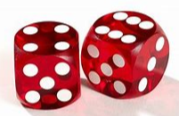
Let’s Roll
Roll the dice then either add the numbers together, times them or use them in a place value grid. For example, 4 and 6 is 46.
Use the 100 square to help work out the answers.

Rules
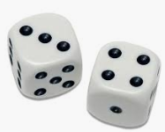
You can add the dice together; multiply the numbers or place them in a place value grid.

3 + 4 = 7
3 × 4 = 12
3 and 4 is 34
Each player rolls the dice and choose which one they want to use for their game.
Then take it in turns to roll the dice to work out the percentage, fraction and decimal. For an added challenge simplify the fraction to it lowest term.
For example,
$\frac{34}{100}$ (÷2) $\frac{17}{50}$
Use the place value grid and 100 square to help you work out the answers.
Tens | Ones

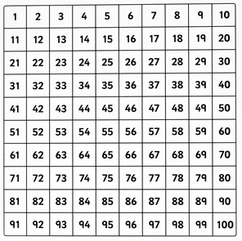

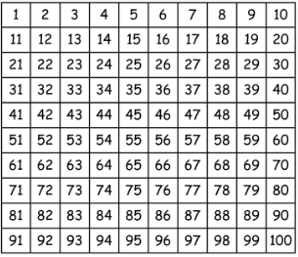

Tens | Ones

